Begin

Input A ($)

B = A \* 23000

Display B (VND)

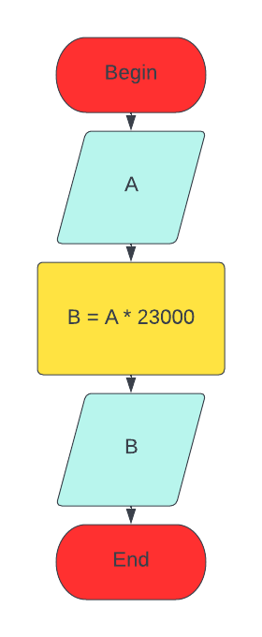End